|  |
| --- |
|  |
|  |

|  |  |  |  |  |  |
| --- | --- | --- | --- | --- | --- |
| REVISION HISTORY | | | | | |
| Ver. | Description of Change | Author | Date | Approved | |
| Name | Effective Date |
| 1.0 | Initial status | Olga_Hilko | 05-DEC-2017 |  |  |

Contents

1. Business Task – Performance of STAR Scheme 3

1.1. BL_3NF 3

1.2. DM_BL 3

1.3. Comparison 4

# Business Task – Performance of STAR Scheme

## BL_3NF

select ct.DESCRIPTION "Тип покупателя",

case when r.Region_name is null then 'Республика Беларусь' else r.Region_name end "Pегион",

ft.RUS_TYPE "Тип топлива", trunc(sum(p.price)) "Выручка"

from BL_3NF.CE_PAYMENT p

left join BL_3NF.CE_PAYMENT_Type pt on pt.ID_SEQUENCE= p.ID_PAyment_type

left join BL_3NF.CE_CUSTOMER c ON c.ID_CUSTOMER=p.ID_CUSTOMER

left JOIN BL_3NF.CE_CUSTOMER_TYPE ct on ct.ID_CUSTOMER_TYPE=c.ID_CUSTOMER_TYPE

left join BL_3NF.CE_FUEL_Type ft on ft.ID_SEQUENCE=p.ID_FUEL_CODE

left join BL_3NF.CE_AZS a on a.ID_STATION=p.ID_STATION

left join BL_3NF.CE_DISTRICT d on d.ID_DISTRICT = a.ID_DISTRICT left JOIN BL_3NF.CE_REGION r ON r.id_region = d.id_region

where p.PAYMENT_DATE between to_date('01/01/2005','mm/dd/yyyy') and to_date('01/01/2015','mm/dd/yyyy')

and ct.DESCRIPTION='Юридические лица'

GROUP BY cube(ct.DESCRIPTION, ft.RUS_TYPE , case when r.Region_name is null then 'Республика Беларусь' else r.Region_name end)

order by 1,2,3

;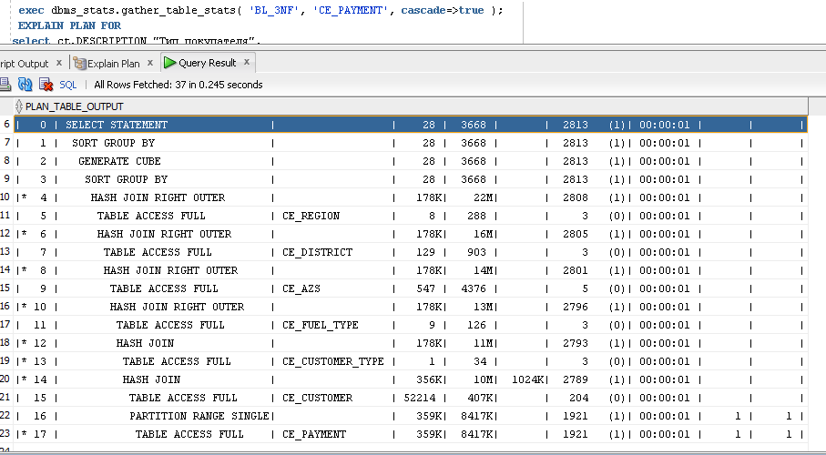

## DM_BL

select

c.CUSTOMER_TYPE_DESCRIPTION "Тип покупателя", a.Region_name "Назв. региона",

ft.RUS_TYPE "Тип топлива", trunc(sum(p.price)) "Выручка"

from BL_DM.FCTPAYMENT p

inner join BL_DM.DIMPAYMENT_Type pt on pt.PAYMENT_TYPE_SURR_ID=p.ID_PAYMENT_TYPE

inner join BL_DM.DIMCUSTOMER c ON c.CUSTOMER_SURR_ID=p.ID_CUSTOMER

inner join BL_DM.DIMFUEL_Type ft on ft.FUEL_TYPE_SURR_ID=p.ID_FUEL_TYPE

inner join BL_DM.DIMAZS a on a.AZS_SURR_ID=p.ID_STATION

inner join BL_DM.DIMDATE d on trunc(p.PAYMENT_DATE)=d.DATE_ID

where p.PAYMENT_DATE between to_date('01/01/2005','mm/dd/yyyy') and to_date('01/01/2015','mm/dd/yyyy')

and c.CUSTOMER_TYPE_DESCRIPTION='Юридические лица'

GROUP BY cube(c.CUSTOMER_TYPE_DESCRIPTION, ft.RUS_TYPE ,a.Region_name)

order by 1,2,3;

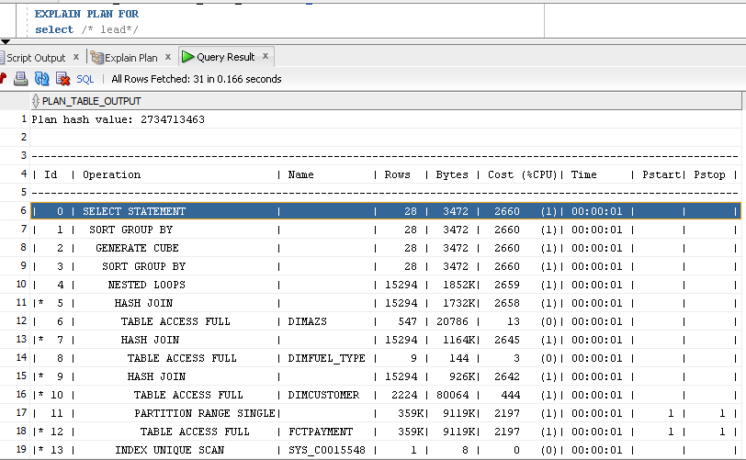

## Comparison

Cost: DM 2660 против 3NF 2813; и время выполнения DM 0.464сек против 3NF 0,521 сек. на фактовой таблице в 1 млн записей.

DM

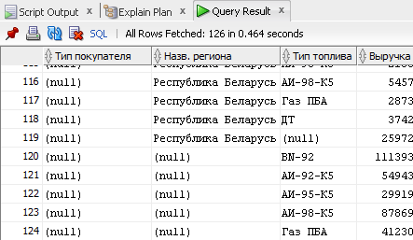

3NF